**Project Lexical Specification**

**Name: Muhammad Bilal**

**ID: F2018266166**

**Section: V1**

Sigma={A-Z,a-z,0-9,int,void,main,cout,cin,id,*,>>,<<,+,,,;,=,(,),{,},space,tab,newline}

Letter={A-Z, a-z}

Digit={0-9}

Keyword={int,void,main,cin,cout}

1. Regular Expression
2. Identifier: Letter ${(Letter|Digit)}^{*}$
3. Int-Literal: ${(Digit)}^{+}$
4. Keyword: covered in Identifier
5. Operator: +, =, *, <<,>>
6. Punctuation: {, }, (, ), ;, ,
7. Delimiter: ${(Space|Tab|newline)}^{*}$
8. DFA:

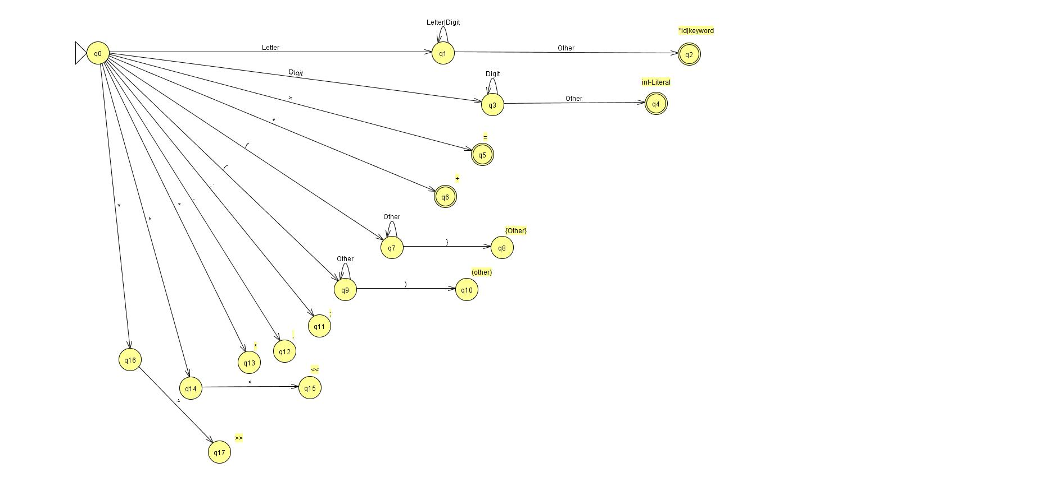

1. Transition Table:

|  |  |  |  |  |  |  |  |  |  |  |  |  |  |  |  |  |
| --- | --- | --- | --- | --- | --- | --- | --- | --- | --- | --- | --- | --- | --- | --- | --- | --- |
| **StateNo** | **Letter** | **Digit** | **=** | **+** | **{** | **}** | **(** | **)** | **;** | **,** | **\*** | **<** | **>** | **Delimiters** | **Accepting State** | **Tokens** |
| 0 | 1 | 3 | 5 | 6 | 7 | 0 | 9 | 0 | 11 | 12 | 13 | 14 | 16 | 0 |  |  |
| 1 | 1 | 1 | 2 | 2 | 2 | 2 | 2 | 2 | 2 | 2 | 2 | 2 | 2 | 2 |  |  |
| 2 | 0 | 0 | 0 | 0 | 0 | 0 | 0 | 0 | 0 | 0 | 0 | 0 | 0 | 0 | Y | Id|Keyword |
| 3 | 4 | 3 | 4 | 4 | 4 | 4 | 4 | 4 | 4 | 4 | 4 | 4 | 4 | 4 |  |  |
| 4 | 0 | 0 | 0 | 0 | 0 | 0 | 0 | 0 | 0 | 0 | 0 | 0 | 0 | 0 | Y | Int-Literals |
| 5 | 0 | 0 | 0 | 0 | 0 | 0 | 0 | 0 | 0 | 0 | 0 | 0 | 0 | 0 | N | = |
| 6 | 0 | 0 | 0 | 0 | 0 | 0 | 0 | 0 | 0 | 0 | 0 | 0 | 0 | 0 | N | + |
| 7 | 7 | 7 | 7 | 7 | 7 | 8 | 7 | 7 | 7 | 7 | 7 | 7 | 7 | 7 |  |  |
| 8 | 0 | 0 | 0 | 0 | 0 | 0 | 0 | 0 | 0 | 0 | 0 | 0 | 0 | 0 | N | { other } |
| 9 | 9 | 9 | 9 | 9 | 9 | 9 | 9 | 10 | 9 | 9 | 9 | 9 | 9 | 9 |  |  |
| 10 | 0 | 0 | 0 | 0 | 0 | 0 | 0 | 0 | 0 | 0 | 0 | 0 | 0 | 0 | N | (other) |
| 11 | 0 | 0 | 0 | 0 | 0 | 0 | 0 | 0 | 0 | 0 | 0 | 0 | 0 | 0 | N | ; |
| 12 | 0 | 0 | 0 | 0 | 0 | 0 | 0 | 0 | 0 | 0 | 0 | 0 | 0 | 0 | N | , |
| 13 | 0 | 0 | 0 | 0 | 0 | 0 | 0 | 0 | 0 | 0 | 0 | 0 | 0 | 0 | N | * |
| 14 | 0 | 0 | 0 | 0 | 0 | 0 | 0 | 0 | 0 | 0 | 0 | 15 | 0 | 0 |  |  |
| 15 | 0 | 0 | 0 | 0 | 0 | 0 | 0 | 0 | 0 | 0 | 0 | 0 | 0 | 0 | N | << |
| 16 | 0 | 0 | 0 | 0 | 0 | 0 | 0 | 0 | 0 | 0 | 0 | 0 | 17 | 0 |  |  |
| 17 | 0 | 0 | 0 | 0 | 0 | 0 | 0 | 0 | 0 | 0 | 0 | 0 | 0 | 0 | N | >> |

1. Lexical Analyzer: See Mini C Language folder